**Assignment and In-class exercises submission using Google Colab and GitHub**

We will use Google Colab + GitHub for in-class exercises and assignment submission. Please follow the following instructions to create a repository for this course and connect it with Google Colab.

**Step 1: Create a new account on GitHub or sign in any existing account:** [**https://github.com/**](https://github.com/)

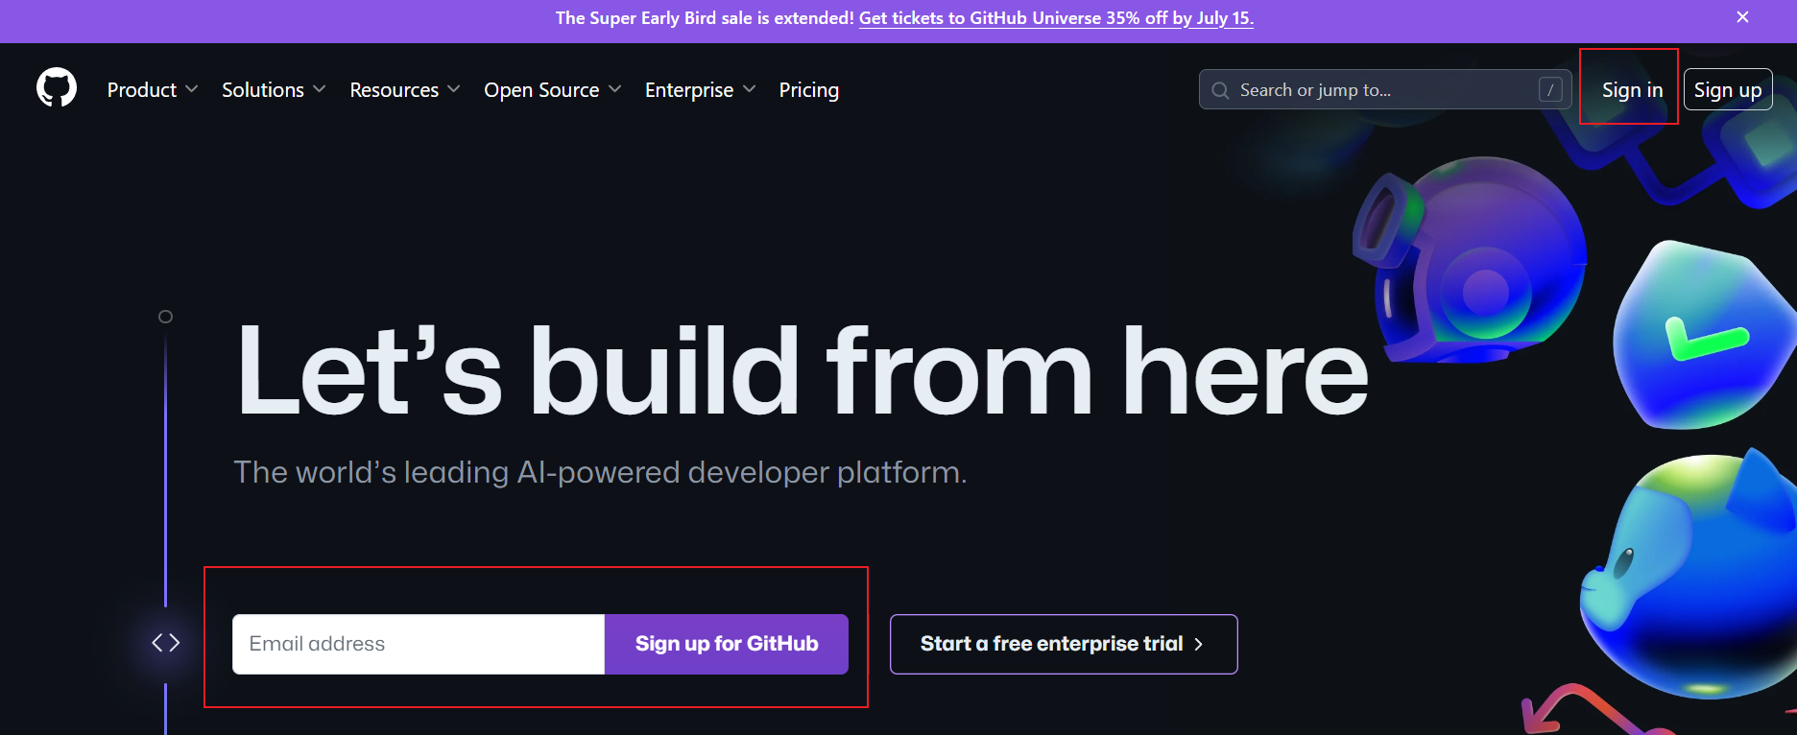

**Step 2: Create a new repository for this course with a common convention for naming as follows: your firstname_INFO5731_Fall2024 (your first name_INFO5731_Fall2024)**

Click **“New”** button on the left side of the window, and you will see the following screenshot, fill the information, and click the **“create repository”** button.

Now you have successfully created a repository for this course in your account, as shown in the following screenshot:

**Step 3: Login Google Colab with your Google account by clicking this link:**

[https://colab.research.google.com/notebooks/welcome.ipynb#](https://colab.research.google.com/notebooks/welcome.ipynb)

**Step 4: Create the first “.ipynb” file by click “File” to choose “New notebook in drive” to write your python code:**

Rename the file, for example, “in_class_exercise_01”:

Then add Code module by clicking **“+ Code”** button or add Text module by clicking **“+ Text”** button.

* **Look at the following example:**

Click **“Run”** under “**Runtime”** to run your code. Remember to save you code (by using Ctrl+S keyboard shortcut)

**Step 5: Save your code in the repository you have just created on GitHub.**

Click **“Save a copy in GitHub”** under **“File”**, as shown below:

Select the repository you have just created for the course, and create a file path to your located file, as shown in the following screenshot:

Now your code has been saved successfully on GitHub:

**Step 6: Copy the link for submitting as your assignment, as shown in the following screenshot:**

**The GitHub code is publicly accessible, which means that you may find your classmates’ submissions. However, if we figure that you copy others’ code, you will certainly be given a zero, without any excuse!**